Laboratory Collection Guidelines for QuantiFERON-TB Gold PLUS
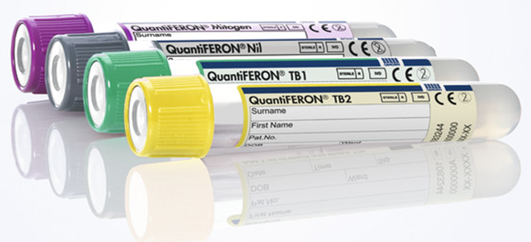Figure 1
One QFT-PLUS test uses the following 4 collection tubes
All four tubes must be collected to perform test (Figure 1):
- Tubes are obtained from the Laboratory.

Filling Tubes
- Tubes should be at Room Temperature at the time of blood filling.
- Collect 1 mL of blood directly into each QFT-PLUS blood collection
tube using a syringe and needle.
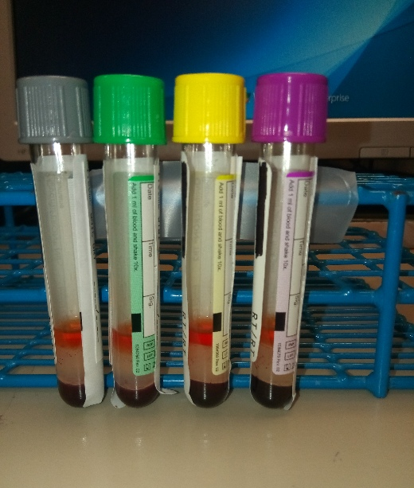
Figure 2. Approved fill volume, image for guidance only
- DO NOT use a butterfly needle for QFT-PLUS collection.
- The black mark on the side of the tubes indicates the 1 mL fill volume.
- If the level of blood in any tube is not close to the indicator line,
another blood sample must be collected. (Figure 2)
- If any of the four tubes is under or overfilled when sent to the laboratory,
the entire specimen will be rejected and MUST be recollected

Mixing
- Antigens are dried onto the inner wall of the blood collection tubes.
- Thoroughly mix tube contents with the blood to dissolve the heparin,
prevent clotting, and resolubilize the stimulating antigen.
- Mixing is performed by shaking the tubes 10 times just firmly enough
to ensure that the entire inner surface of the tube is coated with blood.
Figure 3. A correctly mixed tube
- Frothing of blood in the QFT-PLUS blood collection tubes after the
shaking process is normal (Figure 3).
- Place patient label long way on tubes and DO NOT cover the window
of the tube or the black fill line.

Send to Laboratory Immediately for Incubation
- Tubes must stay at room temperature. Do not refrigerate.

No testing will be performed if tubes are not filled properly

Questions should be directed to your hospital laboratory.

